

SYSC-5104 Methodologies for Discrete-Event Modelling and Simulation

3D-Simulation of Corrosion



**Gurveen Kaur(101088497)**

**Mandeep Singh Bal (101089294)**

**Carleton University**

**Introduction:**

Corrosion is a natural process which converts metal to a more chemically stable state. This leads to gradual destruction of metal due to reaction with the surroundings (Water/moisture etc..). One of the forms of corrosion is rust which is formed on surface of iron exposed to environment.

As rusting (Iron Oxidation) is a very old phenomenon various techniques had been deployed to reduce the destruction of metals such as iron. Corrosion reduces the strength of metal. Iron has a huge economic importance as it is used in many tools and structures. The degradation of iron had led to various accidents and disasters such as collapse of the Mianus river bridge in 1983, when the bearings rusted internally and pushed one corner of the road slab off its support, Silver Bridge disaster of 1967 in West Virginia, when a steel suspension bridge collapsed in less than a minute, killing 46 drivers and passengers on the bridge at the time. The Kinzua Bridge in Pennsylvania was blown down by a tornado in 2003, largely because the central base bolts holding the structure to the ground had rusted away, leaving the bridge anchored by gravity alone.

When exposed surface of metal comes in contact with favourable conditions of corrosion such as water/moisture, oxygen, air or acids. If in case salt is present, then the rusting process increases at a fast rate.

As we know that corrosion is a complex phenomenon dependent on various factors which had been studied over many years. There are many ways to protect corrosion such as Galvanisation, cathodic protection, Coatings and paintings etc.

In this model, we will try to simulate the behaviour of Iron which is coated with the insulating layer such as paint however with a point damage. We will demonstrate how the corrosion start from the point lie geometry which further leads to formation of pit. Then will describe the evolution process of corrosion.

In addition, we will also present the results of this model in different problem when whole of the surface is exposed to the aggressive environment.

Equations shown below explains the process of corrosion: -

Me → Me+

Me+aq + H2O → MeOHaq + H+

H+ + e– → ½H2 (3)

H2O + e– → ½H2 + OH–

Me + OH– → MeOHads + e–

MeOHads + H+ → Me+aq + H2O → MeOHaq + H+

H+ + OH– → H2O

From above equations, it is seen that corrosion happens in presence of water and oxygen.

**Implementation:**

The Cell-Devs implementation shows the two different projects showing the behaviour of iron.

In first we will simulate the behaviour of iron surface which is completely exposed to the environment.

In second we will simulate the behaviour of iron surface which has an insulating layer but with a point damage.

After that we will try to record their results and explain the variations.

In first we will construct a 20*20*2 cell space in which we will show when a metal cell comes in contact and after an appropriate delay the rusting will start which will eventually spread thorough out the metal.

In Second also we will construct a 20*20*2 with zones to show the insulating layer and provide a pin point surface to react with environment and see how the evolution of corrosion occurs on metal.

**Formal Specifications Model: -**

CD = < X, Y, I, S, θ, N, d, δint, δext, τ, λ, D >

X = Ø

Y = Ø

S = { 0, 1,-2,-3,-4}

(0: Bulk Metal, 1: Corrosion, -2: Environment, -3: Insulating material, -4: water molecules)

q = { (s, phase, f, s)}

( phaseÎ{passive, active}, f Î T and s Î R0 + //use inertial delay)

N = neighborhood = { (0,-1,0) (0,0,0) (0,1,0) (-1,-1,0) (-1,0,0) (-1,1,0) (0,-1,1) (0,0,1) (0,1,1) (-1,-1,1) (-1,0,1) (-1,1,1)}

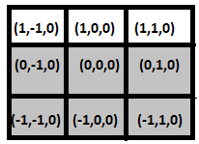 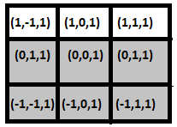

For Plane 0 For Plane 1

d = inertial delay

δint: internal transition function which is defined by CD++ automatically

δext: external transition function which is defined by CD++ automatically

λ: output function which is defined by CD++ automatically

ta(passive) = infinity

ta(active) = d

τ: Local computing function is described as below below: ( .MA file for details)

Rule 1 : (-1,0,0) if cell (0,0,0) = 0 and the value of neighborhood cell (-1,0,0) has a random value which is greater than 0

Rule 2 : {(-1-,1,0)} if cell(0,0,0) = 0 and the value of neighborhood cell (-1-,1,0) has a random value which is is greater than 0

Rule 3 : {(-1,1,0) } if cell(0,0,0) = 0 and the value of neighborhood cell (-1,1,0) has a random value which is greater than 0

Rule 4 : {(0,-1,0) }if cell(0,0,0) = 0 and the value of neighborhood cell (0,-1,0) has a random value which is greater than 0

Rule 5 : {(0,1,0) } if cell(0,0,0) = 0 and the value of neighborhood cell (0,1,0) has a random value which is greater than 0

Rule 6 : (-1,0,1) if cell (0,0,1) = 0 and the value of neighborhood cell (-1,0,1) has a random value which is greater than 0

Rule 7 : {(-1-,1,1)} if cell(0,0,1) = 0 and the value of neighborhood cell (-1-,1,1) has a random value which is is greater than 0

Rule 8: {(-1,1,1) } if cell(0,0,0) = 0 and the value of neighborhood cell (-1,1,1) has a random value which is greater than 0

Rule 9 : {(0,-1,1) }if cell(0,0,0) = 0 and the value of neighborhood cell (0,-1,1) has a random value which is greater than 0

Rule 10 : {(0,1,1) } if cell(0,0,0) = 0 and the value of neighborhood cell (0,1,1) has a random value which is greater than 0

Rule 11: If the cell (0,0,0)=0 and the value of neighborhood cell is -3 then the cell value remains the same

We created the cell space as a 20*20 in which we created 8 neighborhood space to demonstrate a 3d level simulation of corrosion.

Implementation is defined below :-

**Main Model (Corrosion1) :**  It represents the growth of corrosion when a bulk metal is affected due to its environment and water molecules.

[top]

components : Corrosion1

[Corrosion1]

type : cell

dim : (20,20,2)

delay : inertial

defaultDelayTime : 0

border : nowrapped

neighbors : Corrosion(0,-1,0) Corrosion(0,0,0) Corrosion(0,1,0)

neighbors : Corrosion(-1,-1,0) Corrosion(-1,0,0) Corrosion(-1,1,0)

neighbors : Corrosion(0,-1,1) Corrosion(0,0,1) Corrosion(0,1,1)

neighbors : Corrosion(-1,-1,1) Corrosion(-1,0,1) Corrosion(-1,1,1)

initialvalue : 0.0

initialcellsvalue : Corrosion1.val

localtransition : Corrosion-rule

[Corrosion-rule]

rule : {(-1,0,0)+(1.199557)} {(1.199557)*60000} {(0,0,0)=0 and (-1,0,0)!=? and 0<(-1,0,0)}

rule : {(-1,-1,0)+(2.9841534)} {(2.9841534)*60000} {(0,0,0)=0 and (-1,-1,0)!=? and 0<(-1,-1,0)}

rule : {(-1,1,0)+(3.3755746)} {(3.3755746)*60000} {(0,0,0)=0 and (-1,1,0)!=? and 0<(-1,1,0)}

rule : {(0,-1,0)+(4.220230)} {(4.220230)*60000} {(0,0,0)=0 and (0,-1,0)!=? and 0<(0,-1,0)}

rule : {(0,1,0)+(4.6118515)} {(4.6118515)*60000} {(0,0,0)=0 and (0,1,0)!=? and 0<(0,1,0)}

rule : {(-1,0,1)+(1.199557)} {(1.199557)*60000} {(0,0,1)=0 and (-1,0,1)!=? and 0<(-1,0,1)}

rule : {(-1,-1,1)+(2.9841534)} {(2.9841534)*60000} {(0,0,1)=0 and (-1,-1,1)!=? and 0<(-1,-1,1)}

rule : {(-1,1,1)+(3.3755746)} {(3.3755746)*60000} {(0,0,1)=0 and (-1,1,1)!=? and 0<(-1,1,1)}

rule : {(0,-1,1)+(4.220230)} {(4.220230)*60000} {(0,0,1)=0 and (0,-1,1)!=? and 0<(0,-1,1)}

rule : {(0,1,1)+(4.6118515)} {(4.6118515)*60000} {(0,0,1)=0 and (0,1,1)!=? and 0<(0,1,1)}

rule : {(0,0,0)} 0 { t }

**Test Performed:**

**Test Model 1 (Corrosion2) :** It representsthe growth of the corrosion when the bulk metal has a coating of insulating material which prevents corrosion however when the metal comes in contact with its environment it, a pit is created due to damage in insulating material (coating) and from where the corrosion gets started as metal gets reacted with water molecules available on the surface of the metal.

[top]

components : Corrosion2

[Corrosion2]

type : cell

dim : (20,20,2)

delay : inertial

defaultDelayTime : 0

border : nowrapped

neighbors : Corrosion(0,-1,0) Corrosion(0,0,0) Corrosion(0,1,0)

neighbors : Corrosion(-1,-1,0) Corrosion(-1,0,0) Corrosion(-1,1,0)

neighbors : Corrosion(0,-1,1) Corrosion(0,0,1) Corrosion(0,1,1)

neighbors : Corrosion(-1,-1,1) Corrosion(-1,0,1) Corrosion(-1,1,1)

initialvalue : 0.0

initialcellsvalue : Corrosion2.val

localtransition : Corrosion-rule

zone : insulation { (3,0,0)..(17,1,0) }

zone : insulation { (3,0,1)..(17,1,1) }

zone : insulation { (3,2,0)..(4,8,0) }

zone : insulation { (3,2,1)..(4,8,1) }

zone : insulation { (3,11,0)..(4,17,0) }

zone : insulation { (3,11,1)..(4,17,1) }

zone : insulation { (18,0,0)..(19,19,0) }

zone : insulation { (18,0,1)..(19,19,1) }

zone : insulation { (3,18,0)..(17,19,0) }

zone : insulation { (3,18,1)..(17,19,1) }

[Corrosion-rule]

rule : {(-1,0,0)+(1.199557)} {(1.199557)*60000} {(0,0,0)=0 and (-1,0,0)!=? and 0<(-1,0,0)}

rule : {(-1,-1,0)+(2.9841534)} {(2.9841534)*60000} {(0,0,0)=0 and (-1,-1,0)!=? and 0<(-1,-1,0)}

rule : {(-1,1,0)+(3.3755746)} {(3.3755746)*60000} {(0,0,0)=0 and (-1,1,0)!=? and 0<(-1,1,0)}

rule : {(0,-1,0)+(4.220230)} {(4.220230)*60000} {(0,0,0)=0 and (0,-1,0)!=? and 0<(0,-1,0)}

rule : {(0,1,0)+(4.6118515)} {(4.6118515)*60000} {(0,0,0)=0 and (0,1,0)!=? and 0<(0,1,0)}

rule : {(-1,0,1)+(1.199557)} {(1.199557)*60000} {(0,0,1)=0 and (-1,0,1)!=? and 0<(-1,0,1)}

rule : {(-1,-1,1)+(2.9841534)} {(2.9841534)*60000} {(0,0,1)=0 and (-1,-1,1)!=? and 0<(-1,-1,1)}

rule : {(-1,1,1)+(3.3755746)} {(3.3755746)*60000} {(0,0,1)=0 and (-1,1,1)!=? and 0<(-1,1,1)}

rule : {(0,-1,1)+(4.220230)} {(4.220230)*60000} {(0,0,1)=0 and (0,-1,1)!=? and 0<(0,-1,1)}

rule : {(0,1,1)+(4.6118515)} {(4.6118515)*60000} {(0,0,1)=0 and (0,1,1)!=? and 0<(0,1,1)}

rule : {(0,0,0)} 0 { t }

[insulation]

rule : {(0,0,0)} 1 {undefCount >= 1}

rule : {(0,0,0)} 1 {t}

**Test Model 2 (Corrosion3):** It represents the corrosion growth when the metal is fully exposed to the water molecules

[top]

components : Corrosion3

[Corrosion3]

type : cell

dim : (20,20,2)

delay : inertial

defaultDelayTime : 0

border : nowrapped

neighbors : Corrosion(0,-1,0) Corrosion(0,0,0) Corrosion(0,1,0)

neighbors : Corrosion(-1,-1,0) Corrosion(-1,0,0) Corrosion(-1,1,0)

neighbors : Corrosion(0,-1,1) Corrosion(0,0,1) Corrosion(0,1,1)

neighbors : Corrosion(-1,-1,1) Corrosion(-1,0,1) Corrosion(-1,1,1)

initialvalue : 0.0

initialcellsvalue : Corrosion3.val

localtransition : Corrosion-rule

[Corrosion-rule]

rule : {(-1,0,0)+(1.199557)} {(1.199557)*60000} {(0,0,0)=0 and (-1,0,0)!=? and 0<(-1,0,0)}

rule : {(-1,-1,0)+(2.9841534)} {(2.9841534)*60000} {(0,0,0)=0 and (-1,-1,0)!=? and 0<(-1,-1,0)}

rule : {(-1,1,0)+(3.3755746)} {(3.3755746)*60000} {(0,0,0)=0 and (-1,1,0)!=? and 0<(-1,1,0)}

rule : {(0,-1,0)+(4.220230)} {(4.220230)*60000} {(0,0,0)=0 and (0,-1,0)!=? and 0<(0,-1,0)}

rule : {(0,1,0)+(4.6118515)} {(4.6118515)*60000} {(0,0,0)=0 and (0,1,0)!=? and 0<(0,1,0)}

rule : {(-1,0,1)+(1.199557)} {(1.199557)*60000} {(0,0,1)=0 and (-1,0,1)!=? and 0<(-1,0,1)}

rule : {(-1,-1,1)+(2.9841534)} {(2.9841534)*60000} {(0,0,1)=0 and (-1,-1,1)!=? and 0<(-1,-1,1)}

rule : {(-1,1,1)+(3.3755746)} {(3.3755746)*60000} {(0,0,1)=0 and (-1,1,1)!=? and 0<(-1,1,1)}

rule : {(0,-1,1)+(4.220230)} {(4.220230)*60000} {(0,0,1)=0 and (0,-1,1)!=? and 0<(0,-1,1)}

rule : {(0,1,1)+(4.6118515)} {(4.6118515)*60000} {(0,0,1)=0 and (0,1,1)!=? and 0<(0,1,1)}

rule : {(0,0,0)} 0 { t }

**Simulation Results and Comparison’s:**

During simulations and experimentation, We observed that the corrosion start when the cells comes in contact with water and highly aggressive environment and then degrade the metal.

we devised the results that surface which are fully exposes to environment are degraded at a fast pace whereas surfaces with insulation/covering with small defects are corroded at a slow pace as compared to fully exposed metal.

The major point is that in order to prevent the corrosion the metal pieces needs to be properly maintained and serviced using regular coatings of paint as due to aggressive environment variables. Paint can be removed and there is no method of estimate the timing after which metal needs to be coated again.

We also saw that the pit created due to corrosion activity resembles the semi-circular shape which is identical to what happens naturally.

**Results for Main Model (Corrosion1):**

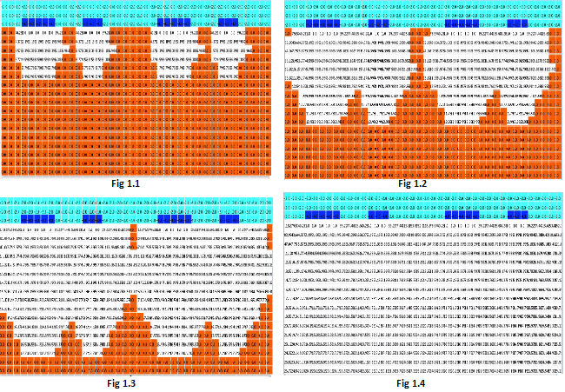

Above mentioned figures represent the corrosion growth in a bulk metal when it comes in contact with the water molecules spread on its surface during different time instances (1/4th of the total simulation time)

Colour representation:

Orange represents bulk metal

Turquoise represent Environment

Blue represents water molecules

White represents corrosion

**Results for Test Model 1(Corrosion2):**

Following figures represents the corrosion growth in a bulk metal (has a coating of insulation material) during different time instances (1/4th of the total simulation time)

Colour representation:

Orange represents bulk metal

Turquoise represent Environment

Blue represents water molecules

White represents corrosion

Black represents Insulating material

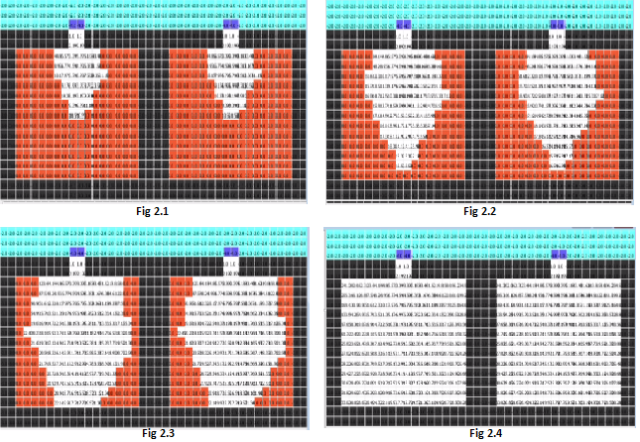

**Results for Test Model 2(Corrosion3):** Following figures represent the corrosion growth in a bulk metal is fully exposed to the water molecules during different time instances (1/4th of the total simulation time)

Colour representation:

Orange represents bulk metal

Turquoise represent Environment

Blue represents water molecules

White represents corrosion

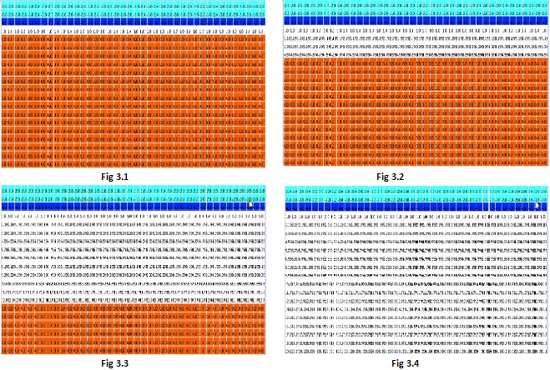

**Conclusions:**

The delay proved very useful in order to simulate the behaviour of corrosion and to gather the understanding of the process at the granular level.

As per the simulation results in order to protect the iron from corrosion using coatings method. Coatings need to be applied after intervals of time in order to avoid the creation of line/point defects.

On the basis of experimentation and simulation, we observed that the corrosion growth rate was more in Test Model 2 (Corrosion3) when the metal was fully exposed to the water molecules it decreases as we reduce the exposed surface from favourable conditions of condition.

In order to completely prevent it we can use regular coatings of paint, galvanisation, cathodic protection in which also sacrificing cathodes need to be renewed on proper interval of time.